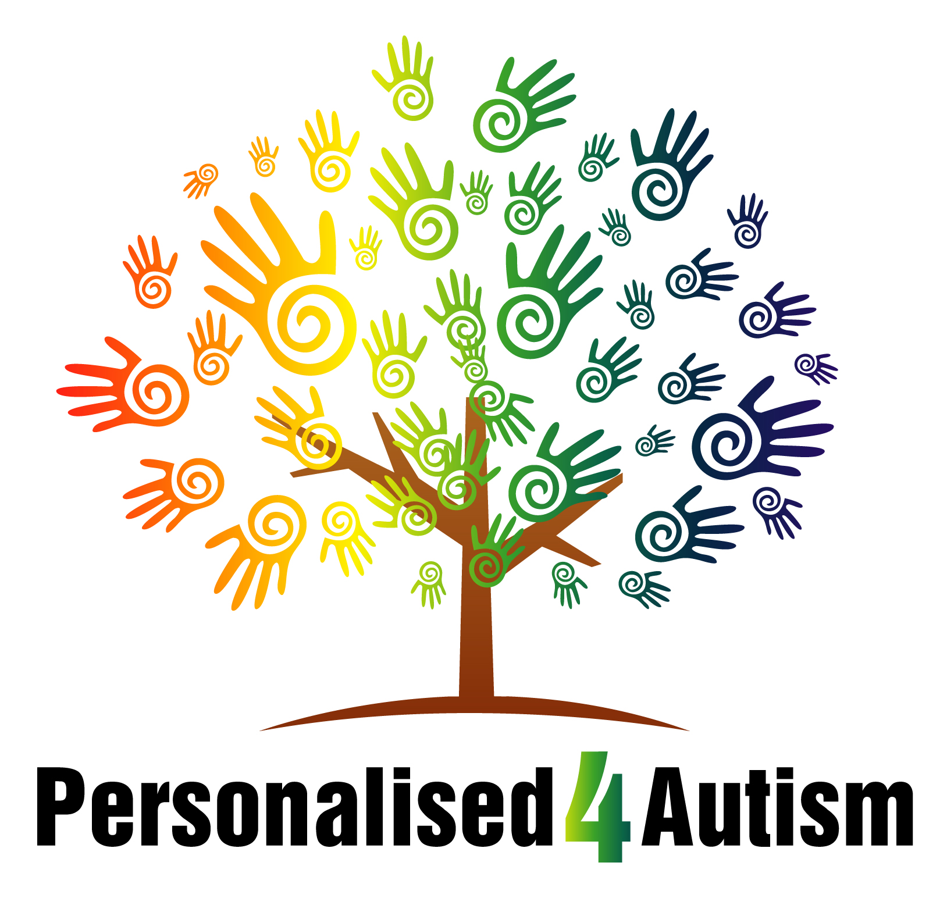
Personalised 4 Autism Northamptonshire service has vacancies whereby you could make a difference to vulnerable adults within our care. By joining our team you will be offering a truly personalised service to children and adults across the autism spectrum. This is an exciting opportunity with many rewards.
We are looking for people across Northamptonshire area, but in particular Northampton itself.

You would be working within a supported living environment or accessing the community via outreach across the county. Supporting individuals with an Autism Spectrum Condition - enthusiasm, drive and the desire to make a difference are all essential requirements of the post.

The successful candidate will contribute to the care plans of individuals and will be expected to bring some personal attributes to the staff team and should be able to carry out day to day activities without direct supervision. A full UK driving license and the ability to transport people is desirable and essential for full time staff.

All posts are subject to an Enhanced Disclosure. An induction is provided which will include coaching and mentoring into the role. There is also the opportunity for further professional development.

All staff will be issued with a rota of social and unsocial hours and full and part time staff will become part of the sleep in rota. Bank staff, have some flexibility and will provide their availability in advance to be allocated shifts.

