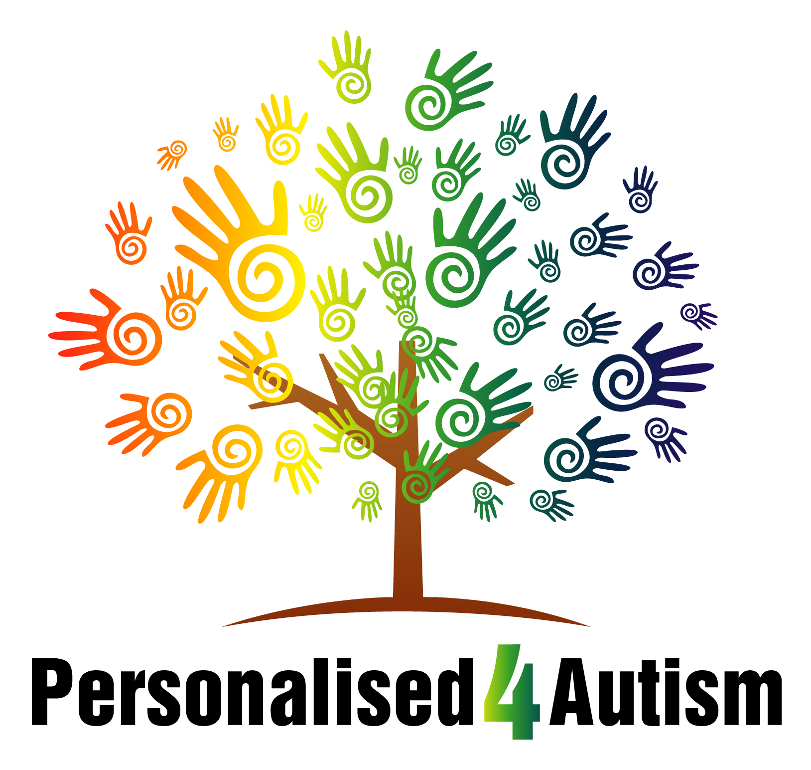

Personalised 4 Autism Employment Application

Name:

Position Applying for:

You must complete all sections of this form – failure to do so will invalidate your application.

Confidential application form
The information provided will be treated as confidential and in accordance with the provisions of the Data Protection Act 1998.

1. Applicant Information
Full Name: |  |  |  | Date:
 | Last | First | Title

Address:

Street Address

 | Town/City | County | Post Code

Phone: |  | Email

Date Available: |  | National Insurance number

Position Applied for:

Driving license (Full UK)? | YES | NO | Date of Birth _______________________  (applicants under 18 years cannot be considered)

Have you ever worked for this company? | YES | NO | Nationality

Do you have a current CRB (enhanced) clearance? | YES | NO

2. Qualifications

Please give details of all your qualifications and relevant courses, including professional qualifications.
Proof of professional qualifications/status will be required before an appointment is made.
Qualifications/ courses | Establishment name  Please continue on back page if necessary | Year of qualification

3. References
Please list three professional references
Please tick if reference may be sought before interview 1. YES 2. YES 3. YES
One of your references must be your current or previous employer
1.  Full Name: |  |  | Relationship:
Company: |  |  | Phone:
Address:
2.  Full Name: |  |  | Relationship:
Company: |  |  | Phone:
Address:
3.  Full Name: |  |  | Relationship:
Company: |  |  | Phone:
Address:

4. Current Employment
Company: |  | Phone:
Address: |  | Manager:

Job Title: |  | Salary: |  | Other benefits:

Responsibilities:

From: |  | To: |  | Reason for Leaving:

4a. Details of all previous employment

Dates of employment  (month & year) | Length of service | Employer’s full name and address | Job title, salary/ other benefits brief description of duties  Please continue on back page if necessary | Reason for leaving

5. Supporting statement
Using the job description please summarize how you feel you meet the requirements/criteria for the role.
Also please highlight how you feel you would be an asset to the people we support and Personalised 4 Autism.

6. Health

a. Are you in good health? YES/NO

b. Are there any medical conditions which may affect your application or your ability to undertake the duties of the position applied for? (If yes please provide details on separate sheet) YES/NO

c. Are you physically able to undertake this work which involves working with children/young adults with learning difficulties & challenging behaviours? YES/NO

d. Are you registered disabled?
(If yes please provide details on separate sheet) YES/NO

7. Safeguarding

The Rehabilitation of Offenders Act 1974 (exception orders)

In compliance with the Rehabilitation of Offenders Act (1974) applicants for positions working with substantial unsupervised access, on a sustained or regular basis to children or young persons must declare all convictions or cautions, be they spent or unspent. Failure to disclose such information could result in subsequent dismissal or disciplinary action if you were appointed. Details of any convictions, cautions or pending court cases should be attached to this application (in a sealed envelope if preferred).

Those who have no (pending) convictions should state here "I have no convictions and/or cautions and/or pending court cases" in their own handwriting.

..............................................................................................................................................................................................

..............................................................................................................................................................................................

I confirm that the information in this application is correct to the best of my knowledge, and understand that wrongful completion will invalidate any contract of employment, which may be offered to me by Personalised 4 Autism Ltd.

Applicant's signature: ………………………………… Date: ....................................

NB: You will be required to produce confirmation of identity if invited to interview in the form of Passport and/or current UK driving license and utilities bill etc.

If you are a foreign national a valid passport and proof of unrestricted work permit must be produced. Failure to produce ID will automatically cancel any proposed employment.

You must have a valid DBS (enhanced) clearance before taking up any offer of employment. All new employees must be cleared through the Disclosure and Barring Service to work with children and vulnerable adults irrespective of any previous clearance you may have. You will be required to complete an application for this and any offer of employment would be conditional on this clearance.

8. General Data Protection Regulation

To help us make an assessment of your skills and match to the available position, we will need to ask you for personal information about you and your experience and training. We will record this information, which will not be shared with anyone without your agreement, and it will be kept in a confidential file which will be kept in a locked filing cabinet.

If you are successful and offered the position, your personal information will be kept in a personnel file held securely electronically. This information will be kept for a period of six years after you have left the company. If you are unsuccessful, your information will be kept securely for a period of six months. It will then be shredded and got rid of in a secure manner. Only Senior Managers will have access to your file if it is required.

You may have access to your notes at any time to see what is actually being recorded. It is the company’s policy that all the information we receive about candidates is confidential and that only those people who need to know the information will have access to it.

The company will always ask your permission before we share with anyone else the information you have given us. In certain circumstances, however, we may need to share information to fulfil our duty of care to you and our service users to keep everyone safe from risk of harm by following the procedures that are set out in the service’s safeguarding policy.

9. Disclaimer and Signature
I certify that my answers are true and complete to the best of my knowledge.
If this application leads to employment, I understand that false or misleading information in my application or interview may result in my dismissal.
Signature: |  | Date:

10. Return completed form

Please return the completed application form to:

‘Recruitment’
Personalised 4 Autism
Suite 409 KG Business Centre
Kingsfield Close
Northampton
Northamptonshire
NN5 7QS

Where did you see this post advertised? .........................................................

11. Office

OFFICE USE ONLY

Date Received.....................................................................

Closing Date (if applicable)..................................................................

Personalised 4 Autism Ltd
Company Number: 8382729
Directors: Patricia Dent & Alasdair Bond

Continued page
Section:…………….

